Task 5: Strategic Recommendations

Task 5.1: Proposed solutions and initiatives

EU Access-to-Space Infrastructure Ecosystem
The recommendations presented in this chapter are framed through an ecosystem perspective in order to capture the interdependencies, bottlenecks and dependencies that shape Europe's ability to provide orbital launch services. Rather than assessing infrastructure categories in isolation, the ecosystem view highlights how launch performance depends on the interaction between industrial, operational and infrastructures, providing the context required to develop coherent and system-level recommendations.
The ecosystem presented in this chapter builds upon the infrastructure mapping and dependency assessment conducted throughout the study, while adapting the broader ecosystem logic specifically to the context of European access to space. The original ecosystem framework was developed around the principle that access, assets and services represent different strategic layers, each characterised by distinct sources of value, vulnerability and control. For access to space, this distinction is particularly important because the critical challenge is not merely the existence of infrastructure, but the ability to maintain autonomous and resilient launch capability across the entire infrastructure chain.Consequently, the ecosystem has been refocused exclusively on the infrastructure required to to provide orbital launch services.
Figure 14 Infrastructure ecosystem of the EU Access to Space
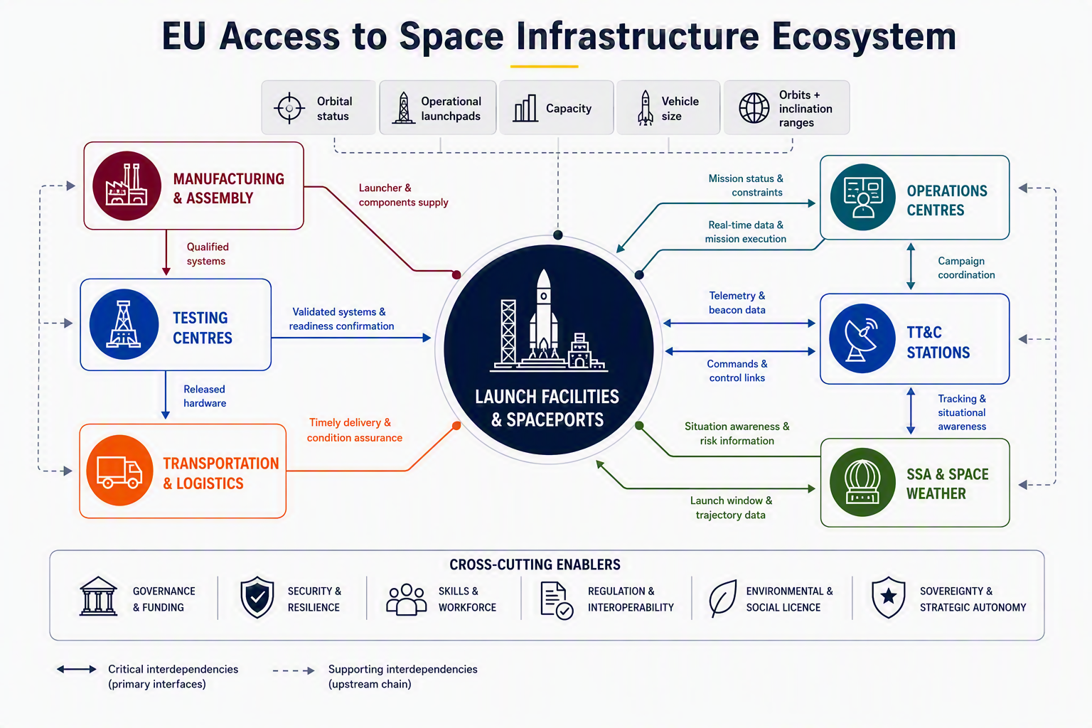
As illustrated in the figure above, Launch Facilities and Spaceports are positioned at the centre of the ecosystem representation, reflecting their role as the primary infrastructure asset around which other access-to-space capabilities are organised.. They act as the key interface between the industrial and operational dimensions of the access-to-space ecosystem.. However, launch facilities do not operate independently. Their performance is inherently dependent on a wider ecosystem of interconnected infrastructure categories, each contributing a specific capability to the overall access-to-space chain.
The industrial layer comprises Manufacturing & Assembly, Testing Centres, and Transportation & Logistics. Together, these infrastructure categories determine the availability, qualification and timely delivery of launch systems to operational launch sites. The operational layer comprises Operations Centres, TT&C Stations and SSA & Space Weather capabilities, which collectively enable campaign coordination, tracking, situational awareness and launch execution. The ecosystem perspective becomes particularly valuable when examining interdependencies, as many of the most critical bottlenecks identified during the study emerge not within individual infrastructure categories, but at the interfaces between them. Several examples illustrate this dependency logic:
- Manufacturing capability only translates into launch capacity when testing infrastructure is available to qualify hardware and certify readiness. For example, Europe's large cryogenic propulsion test capability is concentrated at DLR Lampoldshausen, creating a dependency between launcher manufacturing and a single qualification infrastructure. As identified under A6/A12/B2, capacity constraints, outages or failures at this node can affect multiple launcher families simultaneously.
- Testing infrastructure creates limited value without suitable transportation assets capable of moving qualified hardware to launch sites. The study identified a dependency on the Canopée vessel for Ariane 6 logistics (C1), combined with broader transportation and supply-chain concentration risks (B1/B4), illustrating how logistics constraints can directly affect launch cadence.
- Operations Centres depend on continuous TT&C capabilities to monitor launcher performance and support launch decision-making. The study identified limitations in European-controlled continuous ascent telemetry coverage and the absence of a European TDRS-equivalent relay capability (A5), creating dependencies between operations and TT&C infrastructure.
Therefore, disruptions affecting any of these interfaces can propagate throughout multiple parts of the ecosystem, generating cascading impacts on launch cadence, responsiveness, resilience and strategic autonomy. The study's interface-bottleneck assessment highlights how failures at points such as testing, transportation, TT&C or regulatory interfaces can create system-wide consequences extending well beyond individual infrastructure categories.
The ecosystem should therefore be understood through a dependency thread connecting all infrastructure categories, highlighting how infrastructure availability, capacity, maturity and redundancy collectively determine Europe's ability to provide orbital launch services. Similar to the logic applied in the broader ecosystem framework, the critical question is not whether Europe possesses individual facilities, but whether the interfaces between those facilities provide sufficient capacity, redundancy, interoperability and control to sustain autonomous access to space. A weakness at one point in the chain can propagate upward and constrain the performance of multiple downstream infrastructure categories. Conversely, strengthening a single facility without addressing adjacent dependencies may generate limited system-wide benefits.
This dependency-centric perspective provides the foundation for the recommendations developed in Chapter 6.1.3. Rather than considering each infrastructure category in isolation, the recommendations seek to reinforce the performance of the ecosystem as a whole by addressing critical interfaces, reducing single points of failure, strengthening operational redundancy and improving the overall resilience, security and autonomy of the European access-to-space architecture.

Methodology
The recommendations are developed to translate the study findings into actionable strategic objectives and associated recommendations. The objective is to ensure that each recommendation remains fully traceable to the evidence generated throughout the study while addressing the underlying structural drivers affecting the European access-to-space ecosystem.
The recommendations adopt an ecosystem perspective focused on addressing the political, technical, industrial and operational drivers shaping the long-term development of the European access-to-space architecture.
Figure 14 Recommendation development framework
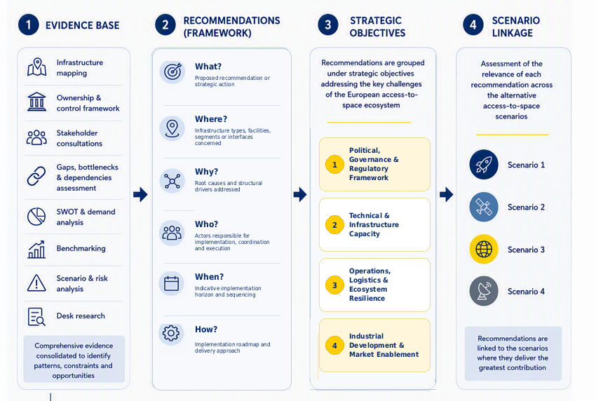
The recommendations draw upon the full body of evidence generated across the report, including infrastructure mapping, ownership and control framework, stakeholder consultations, gaps, bottlenecks, & dependencies assessment, SWOT & demand analysis, benchmarking activities, scenario analysis, risk assessment and complementary desk research. These sources are consolidated to identify recurring patterns, critical constraints and strategic opportunities affecting European access to space.
Each recommendation is subsequently defined using a common assessment framework:
- What? – the proposed recommendation or strategic action.
- Why? – the root causes addressed by the recommendation, taking into account the associated problems and effects identified throughout the analysis.
  - Root causes: the underlying political, governance, technical, industrial, financial and operational factors explaining why identified challenges persist across the access-to-space ecosystem.
- Where? – the infrastructure types, facilities, ecosystem segments or interfaces concerned.
- Who? – the actors involved in implementation, coordination and execution.
- When? – the indicative implementation horizon and sequencing considerations.
- How? – implementation considerations, including feasibility, costs, resource requirements and enabling conditions.
Building on this evidence base, recommendations are grouped under a set of strategic directions reflecting the principal categories of root causes identified throughout the analysis. This ensures that recommendations are organised around the factors driving ecosystem challenges rather than around individual infrastructure assets or stakeholder groups. The strategic directions are structured on four complementary axes.
- Political, Governance & Regulatory Framework: institutional coordination, policy alignment, governance frameworks, strategic planning and public-sector decision-making;
- Technical & Infrastructure Capacity: infrastructure capacity, technological capabilities, facility modernisation, interoperability and technical performance;
- Operations, Logistics & Ecosystem Resilience: industrial competitiveness, supply-chain robustness, investment conditions, financing mechanisms and market development;
- Industrial Development & Market Enablement: operational efficiency, service integration, cross-infrastructure interfaces, information sharing and implementation coordination.
Next, each recommendation is categorised within prioritisation layers:
Priority Tier | Rationale
Tier 1 — Foundational (must-have) | Enable coordination, low CAPEX, high catalytic value
Tier 2 — Flagship transformational | Address top-priority bottlenecks & competitiveness gap
Tier 3 — Enabling | Unlock capacity, reduce friction, protect emerging assets
As a final step, each recommendation is assessed against the alternative access-to-space scenarios developed in Chapter 5. The scenarios do not generate recommendations themselves; rather, they serve as a validation framework to assess the robustness, relevance and adaptability of recommendations under different future access-to-space configurations, investment pathways and risk environments. Recommendations are therefore explicitly linked to the scenarios where they provide the greatest contribution and value.

Recommendation Example
REC-01 — Establish a European Access-to-Space Coordination Mechanism and integrated demand/spaceport portfolio clearing house
What? Create a permanent European coordination mechanism hosted by DG DEFIS and EDA, with ESA as co-lead, Member State space agencies, relevant institutional demand owners and sovereign-adjacent European partners. The mechanism should perform five functions: (i) maintain a rolling multi-annual European Access-to-Space Business Plan covering institutional demand, expected cadence, mission mix, launcher families and site-level capacity; (ii) host a demand clearing house consolidating launch needs from EU programmes, ESA, EUMETSAT, Member States, defence users and research missions over a 5-7 year horizon; (iii) coordinate a European spaceport portfolio strategy covering Level 1: CSG, Esrange, Atlantic Spaceport and Level 2: level 1 + Andoya, SaxaVord ; (iv) maintain an aggregated infrastructure asset and utilisation register; and (v) serve as the operator-facing entry point for multi-site launch concepts, cross-site interfaces and bottleneck escalation.
Where? Cross-cutting across all seven infrastructure categories, with priority interfaces between launch sites, propulsion testing, TT&C, logistics, institutional demand and funding instruments.
Why? The root issue is not simply the absence of one committee, but the separate planning cycles of EU, ESA and national. This has left launch infrastructure, testing capacity, TT&C investment and institutional demand managed through partially disconnected logics. A10 and E11 capture this coordination gap directly, while B8 and E4 show why fragmented launcher initiatives and unpredictable demand weaken industrial maturity. The Letta report also frames space as part of a wider Single Market and strategic-autonomy agenda, supporting the need for scale and coordination rather than purely national approaches. Today, operators face a fragmented landscape: no single European body owns the rolling access-to-space business plan (E11), no recognised access-to-space coordination layer clarifies roles across infrastructure categories (D11), and there is no permanent mechanism to translate gaps, bottlenecks and dependencies evidence identified in task 2.3 into investment priorities (A10). This also affects emerging spaceports: the orbital complementarity of CSG, Nordic sites and the Atlantic Spaceport is not yet translated into a portfolio strategy, leaving persistent exposure to anchor-tenant fragility (E9), exclusive access risks (E10), stranded public investment risks (E6), and the chicken-and-egg funding problem (E3). Norway and the UK should be treated pragmatically as sovereign-adjacent European partners for access-to-space, particularly where launch sites and polar TT&C assets are instrumental to European resilience.
Who? Lead: DG DEFIS and ESA. Structural participants: Member State space agencies, relevant defence demand owners, JRC, CNES for CSG, spaceport operators, launch-service providers, and Norway/UK counterparts for access-to-space cooperation. The mechanism should include an Industry-Startup-Spaceport Forum for structured consultation, but the Forum should advise rather than govern.
When? Short term (now-2028): establish mandate, secretariat, data-sharing principles and first demand-clearing exercise. Medium term (2028-2030): publish the first rolling business plan and portfolio strategy, align with ELC ramp-up and MFF 2028-2034 allocations. Long term (2030-2035): operate as the standing coordination layer for ecosystem-level cadence scale-up and future programme revisions.
How? Use a light but formal mandate rather than a heavy agency structure: secretariat, steering committee, infrastructure-category working groups and secure data-sharing arrangements. The business plan should combine (i) demand forecasts, (ii) infrastructure utilisation, (iii) site-level bottlenecks, (iv) GBD prioritisation, and (v) investment sequencing. The asset register and demand clearing house should reuse the useful logic of former E2 and C8 without creating separate standalone institutions.

Task 5.2: Feasibility, cost, and timeline

Methodology
The recommendations were assessed against three implementation dimensions: feasibility, cost, and implementation timeline.
Feasibility Assessment
Feasibility was assessed using six dimensions reflecting the principal factors that determine whether a recommendation can be successfully delivered:
Table 31 Recommendations - Feasibility assessment - Dimensions
Dimension | Weight | Assessment focus
Technical feasibility | 40% | Maturity of technologies, infrastructure and operational concepts required for implementation.
Financial feasibility | 40% | Ability to mobilise the necessary public and private funding.
Implementation complexity | 20% | Number of actors, interfaces, dependencies and programme-management challenges involved.

Each criterion is scored on a five-point scale, where 1 indicates the least favourable assessment and 5 the most favourable:
Table 32 Recommendations - Feasibility assessment – Criteria scores
Criterion | Focus | 1 | 2 | 3 | 4 | 5
Technical feasibility | Technology and infrastructure readiness | Major technical uncertainty | Significant development required | Further development or demonstration needed | Mature technologies requiring limited adaptation | Proven and available
Financial feasibility | Availability of funding | Financing highly uncertain | Substantial funding gap | Depends on strong political or market support | Additional but realistic funding required | Existing funding sources available
Implementation complexity | Delivery complexity and dependencies | Extremely complex delivery | High programme-management complexity | Multiple dependencies and actors | Manageable complexity | Simple implementation

To support interpretation of the assessment results, weighted scores were translated into qualitative feasibility ratings reflecting the overall ease of implementation.
Table 33 Recommendations - Feasibility assessment – Weighted score
Weighted score | Rating | Interpretation
≥ 4.3 | Very High | Can largely be implemented using existing structures, capabilities and funding mechanisms.
3.6 – 4.29 | High | Requires moderate coordination or investment but faces no major structural barriers.
2.8 – 3.59 | Medium | Achievable but dependent on significant stakeholder alignment, funding or programme decisions.
2.0 – 2.79 | Low | Substantial technical, financial or regulatory barriers must be overcome.
< 2.0 | Very Low | Major structural obstacles make implementation highly uncertain.

Cost Assessment
Cost estimates were developed as indicative order-of-magnitude estimates to support comparison and prioritisation of recommendations rather than detailed budgeting. Estimates are based on the implementation actions envisaged, benchmarking against comparable European and international programmes, evidence from EU, ESA and Member State initiatives, and expert judgement on scale and complexity.
Two cost dimensions were assessed:
- Public funding requirement: expected contributions from EU programmes, ESA, Member States, public infrastructure mechanisms, and programme-management budgets.
- Total investment mobilised: the overall investment expected to be triggered, including public funding, industrial co-investment, private capital, EIB/EIF and InvestEU financing, infrastructure operator contributions, and commercial investments.
For investment-oriented recommendations, total investment mobilised may substantially exceed direct public expenditure.
To provide greater transparency on the nature of the resources required, estimated costs were structured across four broad categories covering infrastructure, operations, programme delivery, and regulatory implementation:
Table 34 Recommendations – Cost assessment - Categories
Category | Scope
CAPEX | Infrastructure, facilities, equipment, digital systems and other physical assets
OPEX | Staffing, maintenance, recurring services and operational activities
Programme management | Governance, coordination, studies, technical support, monitoring and administration
Regulatory & policy | Legal drafting, standards, certification, compliance and implementation support

Given the strategic and long-term nature of the recommendations, cost estimates should be interpreted as indicative rather than precise budget forecasts. Actual implementation costs may vary depending on implementation choices, scope, maturity, and market conditions.

Timeline Assessment
Implementation timelines were assessed using a three-phase model reflecting the typical lifecycle of infrastructure, regulatory and industrial programmes. Estimates consider technical maturity, governance complexity, regulatory dependencies, funding availability, and delivery requirements.
Table 35 Recommendations - Timeline assessment - Phases
Phase | Purpose | Typical activities
Preparation | Establish the foundations for implementation | Policy development, governance setup, stakeholder alignment, feasibility studies, regulatory preparation, funding approval
Implementation | Deliver the recommendation | Procurement, infrastructure development, technology qualification, regulatory adoption, deployment of capabilities
Operationalisation | Scale and sustain the implemented solution | Routine operations, service expansion, performance optimisation, ecosystem adoption, integration into long-term planning

To facilitate comparison across recommendations, implementation timelines were categorised into three indicative profiles reflecting the expected duration and scale of implementation.
- Short-term (1-3 years): governance measures, studies, regulatory actions, coordination mechanisms and other relatively quick-to-deploy initiatives.
- Medium-term (3-7 years): infrastructure upgrades, technology development and qualification, and programme deployment activities.
- Long-term (7-10+ years): major infrastructure investments, industrial transformation initiatives, and ecosystem-scale capacity expansion programmes.

Roadmap Example
REC-01 — European Access-to-Space Coordination Mechanism (EATSCM)
Purpose: Permanent DG DEFIS-hosted, ESA-co-led coordination layer covering rolling business plan, demand clearing house, spaceport portfolio strategy, asset register and multi-site operator interface.
Feasibility MCA
Dimension | Technical | Financial | Complexity | Weighted
Score | 5 | 5 | 3 | 4.33 / High

Cost Stack
Item | Range | Type | Basis
Setup (legal mandate, data platform, IT security, initial register) | €5 – 8 M | CAPEX | Task 5.1 prior draft
Secretariat (~20 FTE) + steering/working groups | €3 – 5 M / yr | OPEX | Task 5.1 prior draft
Annual demand-clearing studies, portfolio analysis, external expertise | €1 – 2 M / yr | OPEX / Prog. mgmt | Comparable EU coordination bodies (EU SST, EU Chips Board)
Total public 2026–2035 | €30 – 60 M

Timeline
Phase | Period | Key milestones
Preparation | 2026–2028 | Mandate, secretariat set-up, first demand-clearing exercise
Implementation | 2028–2030 | First rolling business plan, portfolio strategy alignment with ELC and MFF 2028–2034
Operationalisation | 2030–2035 | Standing coordination layer supporting cadence scale-up

Enrico Letta, Much more than a market, April 2024, including sections on financing strategic goals and the Single Market and space as a lever for strategic autonomy.

